


Experiment results report
“YOLO Object Detection System”
By Kittisak Petchnamkhang ID: 6601023611019
Prepared by
Professor Jiraphan Inthiam
At The Missing Semester of Your RE

Table of Contents

1. System Overview 3
2. Build & Deployment Phase 3
2.1 Build Pipeline Steps 3
3. Runtime Architecture 3
3.1 Components 4
3.2 End-to-End Request Flow 4
4. Workflow Explanation 4
4.1. Build & Deployment Phase 4
4.2. Image Detection Workflow 4
4.3. Data Flow 5
5. Network Design & Security 5
6. Technology Stack 6
7. Summary 6
8. References 6

1. System Overview
This document describes the architecture and deployment workflow of a containerized object detection service built on YOLOv8. The system enables users to upload images via a web browser and receive real-time inference results with annotated bounding boxes.
The solution is fully containerized using Docker Compose and consists of two main services:
- Nginx — Acts as a reverse proxy gateway, listening on Port 80
- AI Service — A FastAPI application running YOLOv8 inference on Port 8000 (internal)
Both services communicate through a dedicated Docker virtual bridge network, keeping the AI service isolated from direct external access.

2. Build & Deployment Phase
The entire system is deployed with a single command:
$ docker compose up --build

2.1 Build Pipeline Steps
Docker Compose executes the following steps sequentially:
Step | Action | Description
1 | Download Layers | Pull base images: Python runtime, Nginx web server, and YOLOv8 model weights
2 | Pack Images | Build Docker images from Dockerfiles for each service
3 | Create Virtual Network | Establish an internal bridge network for inter-service communication
4 | Start Services | Launch all containers (Nginx + AI Service) in the correct dependency order

3. Runtime Architecture
Once deployed, the system operates within a Docker environment consisting of two networked containers and external user-facing components.

3.1 Components
Component | Location / Port | Role
User (Browser) | External | Selects an image and initiates a detection request
Nginx | Docker — Port 80 | Receives HTTP requests; acts as reverse proxy to the AI service
AI Service (YOLOv8) | Docker — Port 8000 (internal) | Runs inference, computes bounding boxes, returns JSON results
Virtual Network | Internal bridge | Isolates and connects Nginx and AI Service containers
Browser (Result Display) | External | Renders the annotated result image returned by the API

3.2 End-to-End Request Flow
The following sequence describes a complete inference request from the user to the browser:
# | Stage | Details
① | User Action | User selects an image in the browser and clicks "Detect"
② | HTTP Request | Browser sends POST /api/predict with binary image payload to Nginx on Port 80
③ | Proxy Pass | Nginx forwards the request to AI Service (Port 8000) via the internal virtual network
④ | YOLOv8 Inference | AI Service processes the image: runs YOLOv8 model, calculates bounding boxes and class labels
⑤ | JSON Response | AI Service returns structured JSON (detections, coordinates, confidence scores) to Nginx
⑥ | Display Result | Nginx forwards JSON to the browser; browser renders the annotated image with bounding boxes

4. Workflow Explanation
The system workflow explains how the application is built and how image detection works through the AI service. It consists of two main phases: Build & Deployment and Image
Detection.

4.1. Build & Deployment Phase
The process starts when the developer runs the command docker compose up --build. Docker builds the required images by downloading components such as Python, Nginx, and YOLO libraries.
After that, Docker creates a virtual network and starts the containers. Nginx runs on port 80 as the entry point, while the AI service runs on port 8000 and loads the YOLOv8 model to wait for detection requests.

4.2. Image Detection Workflow
When the system is running, the user uploads an image from the browser and clicks Detect. The browser sends the image to /api/predict.
The request first goes to Nginx, which forwards it to the AI service through the internal Docker network.
The AI service processes the image using YOLOv8 to detect objects and generate bounding boxes. The detection result is converted into JSON and sent back through Nginx to the browser. Finally, the browser displays the detection result on the screen.

4.3. Data Flow
Browser → Nginx → AI Service (YOLOv8) → JSON Result → Browser Display
This architecture separates the web gateway (Nginx) and the AI processing service, making the system easier to manage and scale.

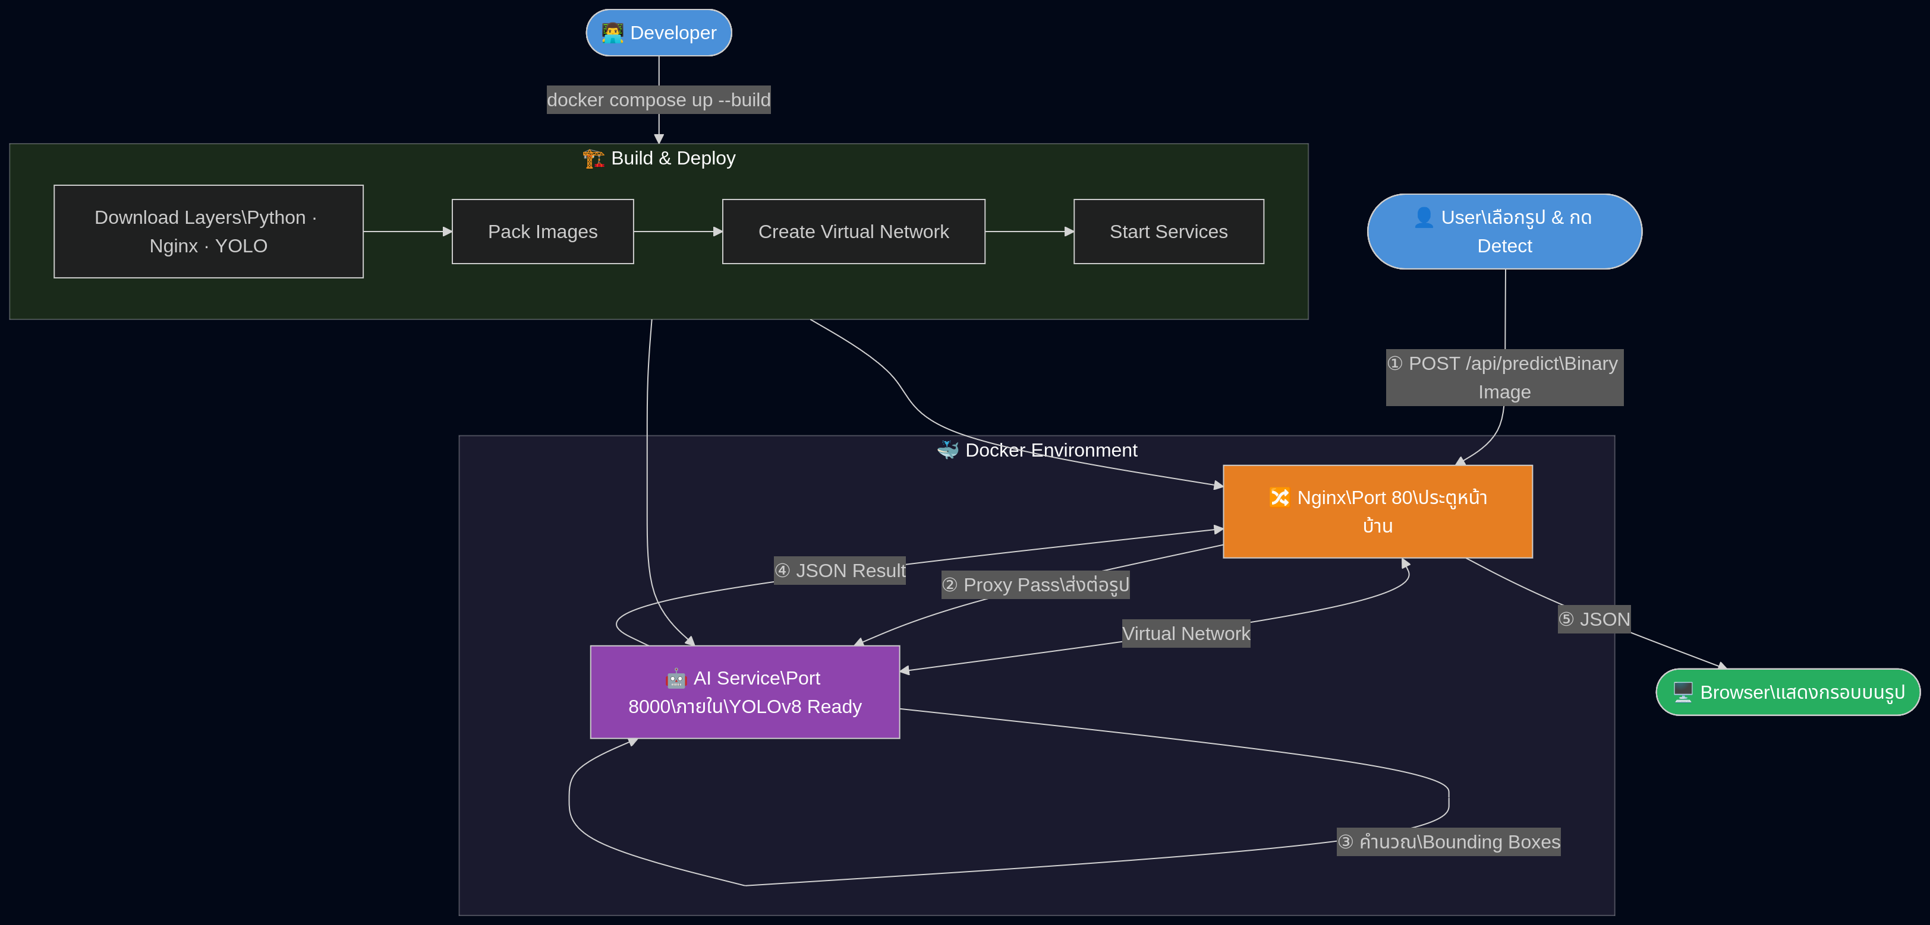

5. Network Design & Security The architecture follows a defense-in-depth approach by separating external traffic handling from AI inference:
- The AI Service is never directly exposed to the internet — only Nginx has an external port binding (Port 80).
- All internal communication between Nginx and the AI Service occurs over the Docker virtual bridge network, invisible to external clients.
- Nginx enforces a single entry point, enabling future addition of rate limiting, SSL/TLS termination, and authentication middleware without modifying the AI service.

6. Technology Stack
Technology | Version / Type | Purpose
Docker Compose | v2.x | Container orchestration and service lifecycle management
Nginx | Latest stable | Reverse proxy, load balancer, static file serving
YOLOv8 (Ultralytics) | v8.x | Real-time object detection deep learning model
Python / FastAPI | 3.x / latest | AI service web framework and async API server
Docker Bridge Network | Virtual | Isolated inter-container communication channel

7. Summary
The YOLO Object Detection System demonstrates a clean, production-ready containerized microservices pattern. By separating concerns between the gateway layer (Nginx) and the inference layer (AI Service), the architecture achieves:
- Security: AI inference is isolated from direct external access
- Scalability: Each service can be scaled independently
- Simplicity: One-command deployment via Docker Compose
- Maintainability: Clear separation of responsibilities between services
The workflow from developer trigger (docker compose up --build) to user-facing result is fully automated and requires no manual intervention once deployed.

8.References
- Docker Documentation.
Docker Inc. (2024). Docker Documentation.
https://docs.docker.com/
- Nginx Documentation.
F5 (2024). NGINX Official Documentation.
https://nginx.org/en/docs/
- FastAPI Documentation.
Sebastián Ramírez (2024). FastAPI Framework Documentation.
https://fastapi.tiangolo.com/
- YOLOv8 Documentation.
Ultralytics (2024). Ultralytics YOLO Documentation.
https://docs.ultralytics.com/
- Python Software Foundation.
Python Software Foundation. (2024). Python Documentation.
https://docs.python.org/3/

